**ECEN 325 - Lab Report**

**Lab Number: 10**

**Lab Title: Characterization of the MOSFET**

**Section Number: 503**

**Student’s Name:** [Alex Allahar](mailto:alex.allahar@tamu.edu)

**Student’s UIN: 928009686**

**Date: 11/12/23**

**TA: Mike Ng**

1. **Measurement Plots**

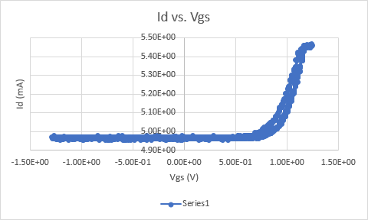

1. **Id vs Vgs (2N7000G)**

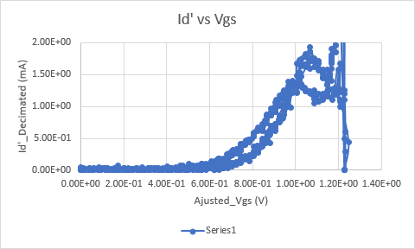

1. **ID` vs. Vgs (2N7000G)**

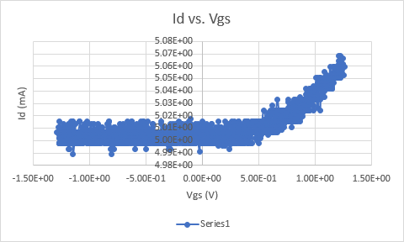

1. **Id vs Vgs (CD4007N)**

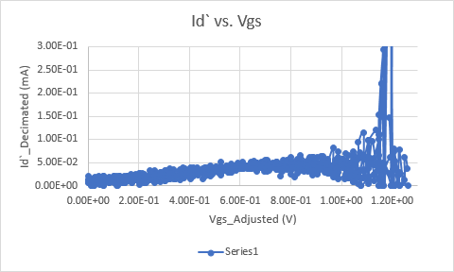

1. **ID` vs Vgs (CD4007N)**

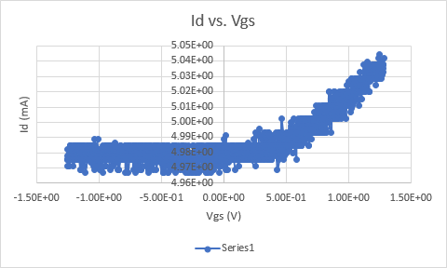

1. **Id vs Vgs (CD4007P)**

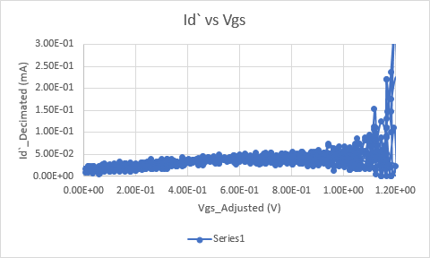

1. **ID` vs Vgs (CD4007P)**
2. **Tables**

| Value | Measurement |
| --- | --- |
| Vt (2N7000G) | 0.7 V |
| k`W/L (2N700G) | 5 V |
| Vt (CD4007P) | 0.95 V |
| k`W/L (CD4007N) | 1 mA |
| Vt (CD4007P) | 0.95 V |
| k`W/L (CD4007P) | 1 mA |

1. **Compare the results and comment on the differences**

The Excel functions provided by the lab manual did not work at first; however, changing the decimation factor helped to create models similar to the ones found in the prelab. The CD4007 chip behaved as an NMOS and PMOS depending on the DC value when sweeping. This is due to the CMOS chip having both p and n good bodies inside.